**Discover The Travel Road Tay Bac Ha Noi - Sapa - Lai Chau**

*Attention:*

-Departure point: Hanoi

-Time: 3 days 2 nights

-Media: car

-Price: 3000000đ to 2400000đ.

-Image:

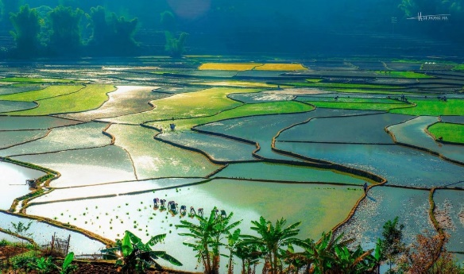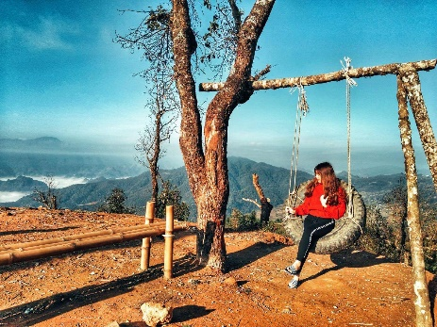

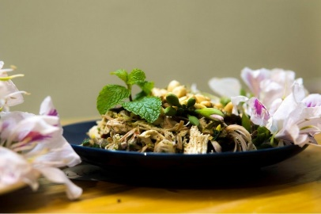 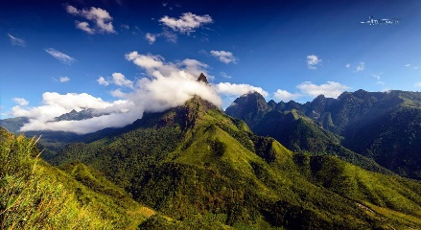 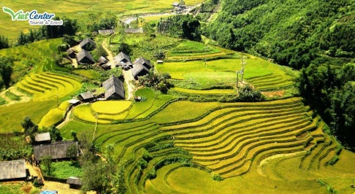 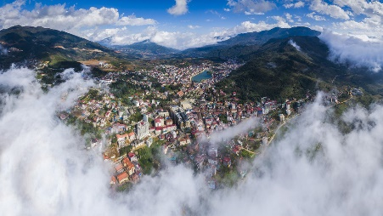 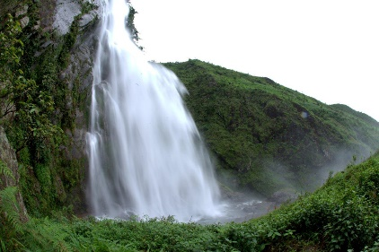 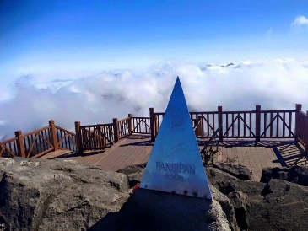

**I.Introduce:**

**Discover The Travel Road Tay Bac Ha Noi - Sapa - Lai Chau**

You will experience the beautiful Northwest travel route in the journey, Hanoi - Sapa - Lai Chau

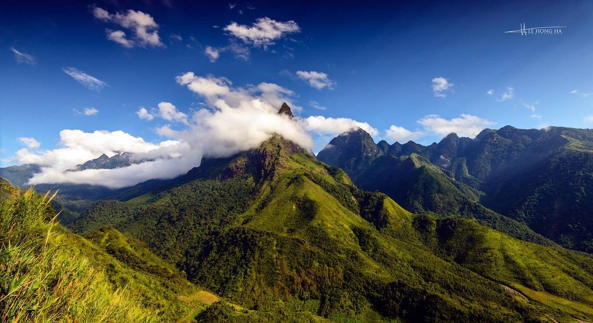

Located on the majestic Hoang Lien Son range of Northwest Vietnam, the place of Sapa and Lai Chau are famous places with challenging roads like thin thread across the mountain range, with terraced fields stretching from top of the hill, gently sloping to the base of a shiny gold color. Come to Northwestern Vietnam to experience "The First Four Great Deo", nature, terraced fields and extremely special culture of the local ethnic minorities and many unique culinary features.

**II.** **Tour schedule:**

**1.Day 1:**

**HA NOI – FANSIPAN – LAI CHAU** _____________________________________________________________________

06h00: Car and guide of Vietnam Travel Center pick you up at the gate of Thong Nhat Park - Tran Nhan Tong Street depart for Sapa. On the way, you will rest and have breakfast at the roadside station on Noi Bai - Lao Cai Expressway. 11h30: Arrive in Sapa, you rest, lunch at local restaurant. 13h00: Drive to Fansipan cable car station. You conquer Fansipan peak take souvenir photos (Self-payment costs).

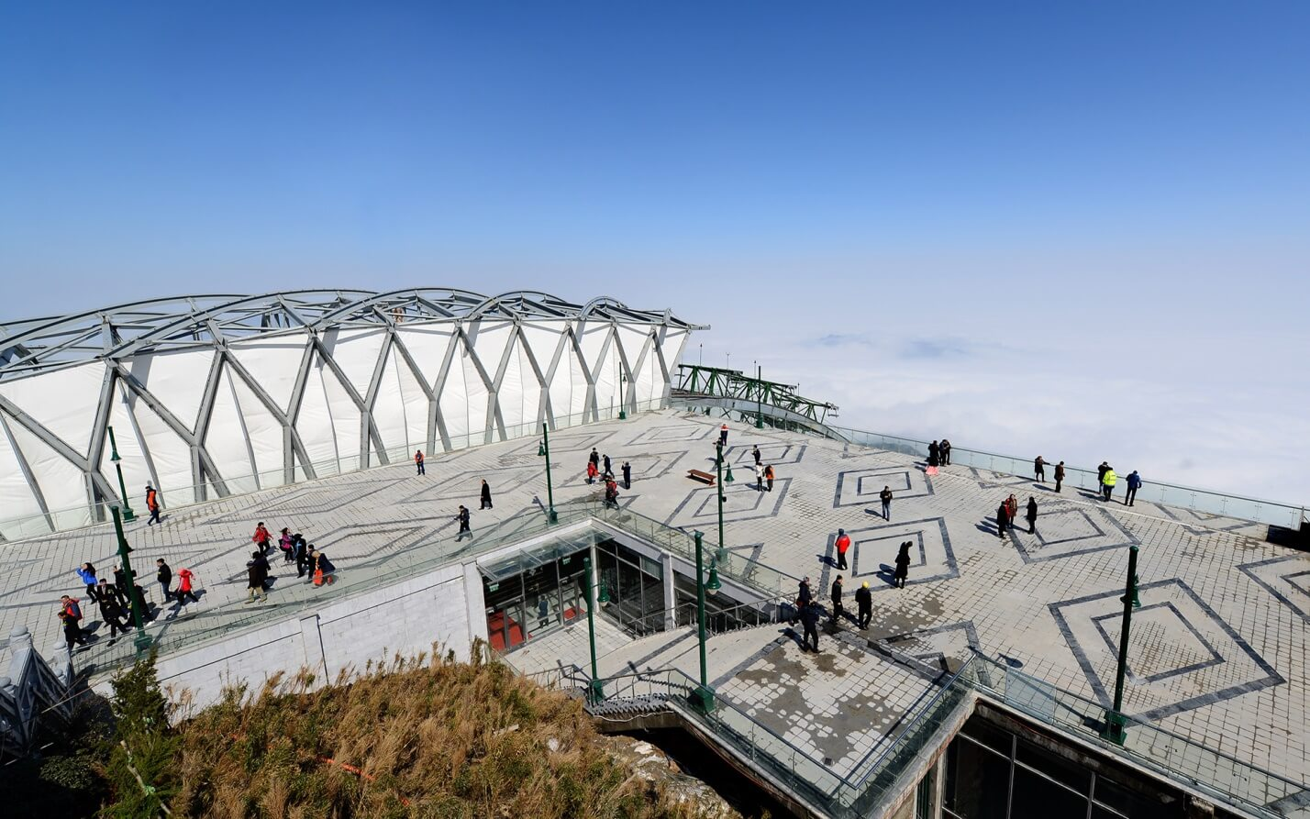

16h00: Continue the journey to visit Silver Falls, Heaven Gate. You pass through O Quy Ho Pass - One of the Four Great Peak Passes of Vietnam to Lai Chau.

17h30: Arrive at Tam Duong, you check in hotel. Freedom to rest.

18h40: Have dinner at local restaurant. _____________________________________________________________________

**2.Day 2:**

**EXPLORE LAI CHAU** _____________________________________________________________________

Morning: Have breakfast. Car takes you to conquer Putaleng peak to visit Tinh waterfall, Si Thau Chai - home to 60 ethnic households of Dao Dau Bang. Here, you are immersed in the life of the local residents with the pristine walled houses, orchid garden, peach garden, Tam Giac Mach flower garden, paragliding performance venue ... Have lunch at home. local goods.

Afternoon: Car takes you to visit the Tien Son Mobile Relic with 36 cave caves and shimmering stalactite system along the stream across the four clear seasons. Farewell Tien Son cave, you visit Tham village - the residence of the Lu people - one of the smallest ethnic groups in Vietnam. Back to Tam Duong, Have dinner, free to explore Tam Duong at night. _____________________________________________________________________ **3.Day 3:** **LAI CHAU - HA NOI** _____________________________________________________________________

Morning: Have breakfast. Car to take you to visit Phieng Tien tourist area. You cross the suspension bridge across the Nam Mu River into Phieng Tien tourist area. Free to visit, take souvenir photos at the suspension bridge, water (water reel), colorful Northwestern flower gardens or unique handmade models ... Continue the journey, you visit and take photos save Concerning at Tam Duong Tea Hill, visiting the upland clean tea production process, listening to the introduction to the origin of different types of tea and enjoying free tea. Free shopping for goods and souvenirs. Car to take you back to Sapa. Have lunch. Afternoon: Drive back to Hanoi. On the way, you will rest at the roadside station of Noi Bai - Lao Cai. 18h30 to Hanoi, the car takes you back to the original meeting point. Break unions, ending the tour. _____________________________________________________________________

**III.** **INCLUDED AND TERMS: TOUR PACKAGE PRICE FOR 01 GUEST: Service includes:** • New passenger car with 29 seats serving the delegation according to the program. Friendly and enthusiastic driving. • 2-star hotel; 2 pax / room, in case of odd group because of gender, put 3 pax / room. • Meals according to program standards: 150,000 VND / person / meal (05 main meals)• One-time admission to attractions in the program. • Drinking water on the car 01 500ml bottle / person / day. • Guided shuttle to visit the program. • Travel insurance by day of tour, maximum reimbursement: VND 30,000,000 **The service does not include:** • Drinks at restaurant meals. • Laundry, minibar, telephone, ... and other personal expenses out of the program. • 10% VAT. • Tips for tour guides and drivers. • Air ticket (train) round trip **Note:** • Children under 5 years old, eat, sleep in the same bed with parents: Free, however 2 adults can bring only 1 child, from the 2nd child 50% of the tour price (Parents pay extra cable car if children with a height of 1m or more) • Children from 5-9 years old, sharing a bed with parents: Calculate 70% of the tour (Separate rate, sleeping with parents). • Children 10 years and older: Calculated as adults. **Regulations on Fansipan cable car fare:** • Height: Equals and less than 1 m: Free cable car ticket. • Height from over 1m - 1.3m: Price 500,000 VND / round trip. • Height above 1.3m: Price 700,000 VND / round trip. **Note:** • The trip schedule may be changed to suit the actual conditions and circumstances, but still ensure the full range of attractions in the program.